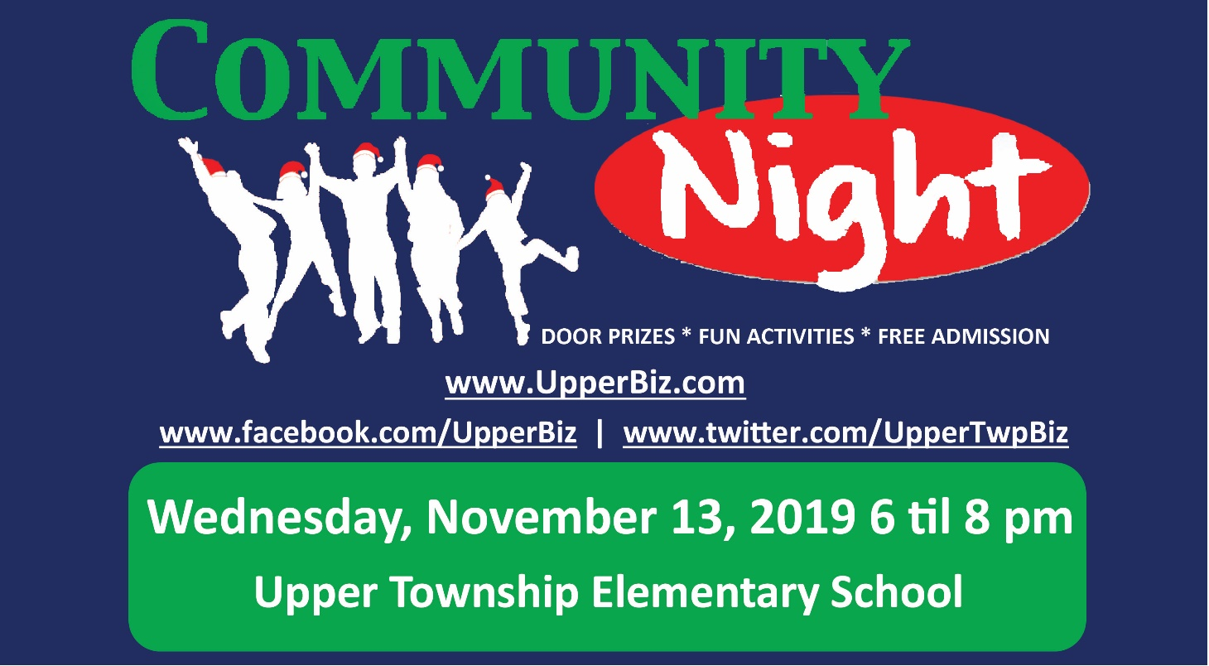P

***Start your celebration and holiday shopping with us!***



**Greet the festive season with an evening of fun!**

* **Free Admission**
* **Over 50 Tables**
* **Fun Activities**
* **“Creation Station” for Kids**
* **Door Prizes & Giveaways**
* **Special Guest Photo Opportunity**
* **Shop for Unique Gifts from Local Businesses**
* **Exclusive Offers for #SmallBusinessSaturday**

**Presented by**

